**Project Design Phase-I Solution Architecture**

|  |  |
| --- | --- |
| Date | 02 November 2022 |
| Team ID | PNT2022TMID40047 |
| Project Name | Smart Waste Management system for Metropolitan Cities |
| Maximum Marks | 4 Marks |

**Solution Architecture Diagram:**

Transformer

Regulator

Work station

Dustbin with Ultra sonic sensor

Arduino

App

notificat

ion

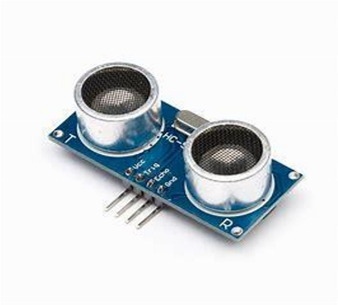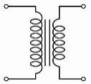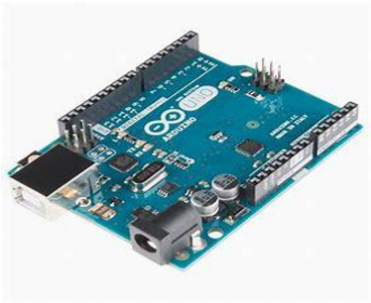

Web

serve

r